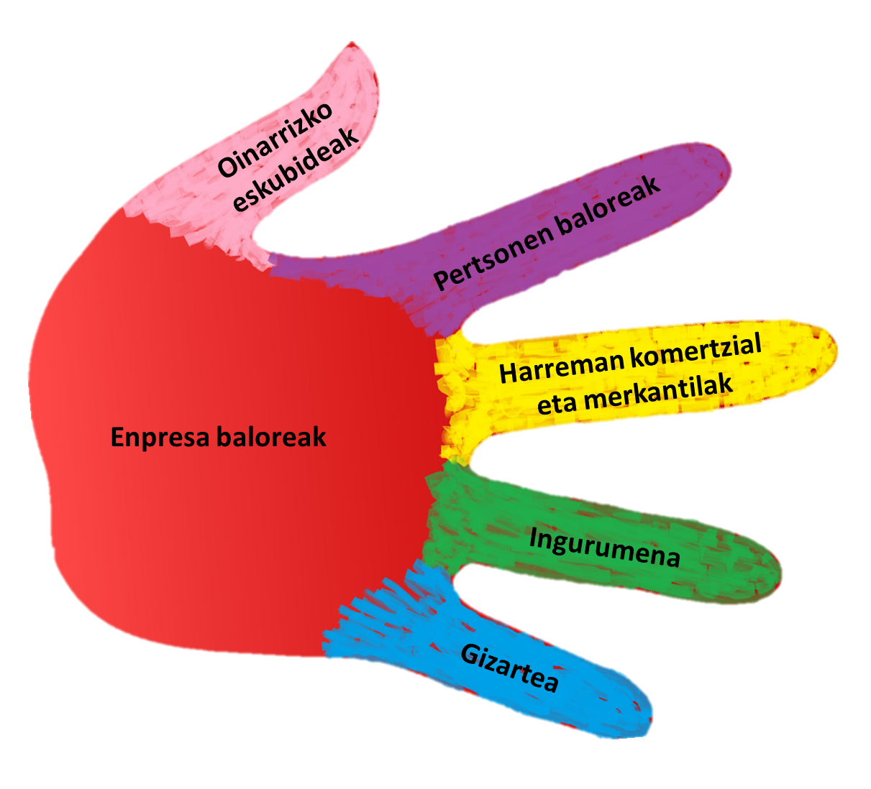

Code of Ethics

Index

1. Elay Group Code of Ethics 3
2. Purpose of the Elay Group 4
3. Company Values 4
4. Personal Standards for Elay Group Members. 5
5. General Standards 7
6. Standards in Sales and Market Relations 7
7. Relations with Government Organisations 8
8. Occupational Health and Safety 8
9. Society 8
10. Environment 9
11. Compliance with Regulations 9
12. The Code of Ethics, a Living Document 10

Elay Group Code of Ethics
This Code of Ethics outlines the ethical principles that guide the Elay Group, and is both applicable to and binding for all those who act in the name of the Elay Group.

Purpose of the Elay Group
The purpose of the Elay Group is to create wealth over the long term, with the end goal of distributing this wealth, both directly – through profit-sharing, salaries, purchases, subcontracts, and other means – and indirectly – through the payment of taxes, charitable donations, and more – wherever the Elay Group is present.
The health, safety, and wellbeing of all those who form a part of the Elay Group is guaranteed to the greatest degree possible by ensuring that all necessary means and measures to achieve these ends are put into place.
The purpose of all people who make up the Elay Group is to provide value for our customers. The present Code of Ethics is a guide for our attitudes, actions, and relations, which is to be followed so as to provide the greatest value possible.

Company Values
The values embraced by the Elay Group are as follows:
- Honesty. Complete honesty is the standard for all interactions with workers, customers, suppliers, and all other stakeholder groups.
- Total Fulfilment of All Commitments.
- Respect and Non-Discrimination. All people who make up the Elay Group shall demonstrate absolute respect for the people and groups with whom they interact, including co-workers, customers, suppliers, visitors, public institutions, and any other stakeholders or other relevant parties.
Aggressive behaviour, including any type of violence, threats, or intimidating acts, will not be tolerated. All people shall be treated as equals, with dignity and respect, regardless of race, colour, age, gender, sexual orientation, religion, nationality, ideology, socio-economic status, or culture.
In all matters concerning work relationships, applicable laws shall be adhered to. Given that the goal is the improvement of both people and society, our work must not be limited to mere legal compliance.
- Social Commitment. We shall take care of our surrounding communities and actively participate in their improvement.
- Environmental Commitment. Respect for and protection of the environment are guidelines under which the company shall operate at all times.
- Re-Investment. The Elay Group guarantees that the investments necessary to sustain and develop the company into the future shall be made.

Personal Standards for Elay Group Members
These are the standards and behaviours that we consider to be fundamental for the people who make up Elay. It is the company’s responsibility to encourage and foster these standards in collaboration with Group members, always respecting the limitations of each individual.

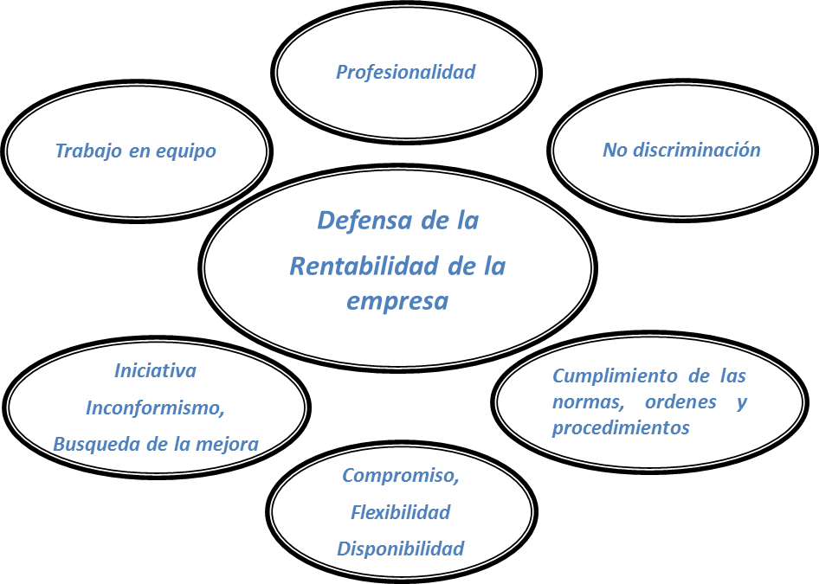

- Sustain Profitability. It is the responsibility of all Elay members to advance and maintain the company's profitability, each from their respective department and position.

- Professionalism. Guaranteeing the safety of both people and resources, and keeping clients’ needs always in mind, we will do everything in our power to perform our work unerringly and on time.

- Teamwork. Teamwork shall be prioritised as the modus operandi for work at Elay, both promoting involvement and making it possible.

- Initiative, Key to Improvement. We seek to improve our ways of working, striving always to understand the deeper reasons for our actions. We must maintain a proactive attitude, searching for, proposing, and enacting possible improvements and developments in all departments.

- Flexibility and Availability. Both the company and all those who form a part of it shall remain flexible, adapting to each situation so as to continue offering satisfactory solutions to all stakeholder groups and any other parties with whom we have direct contact.

- Compliance with Standards and Procedures. We are committed to complying with all standards and procedures established in the company.

- Equality and Non-Discrimination. Anyone with either suspicion or knowledge of any act in violation of the basic rights of any party directly or indirectly connected to the Elay Group, is obligated to make the act known to company managers or representatives, so as to quickly adopt the measures necessary to restore the rights of the person or persons concerned.

General Standards
- All information will be kept confidential according to the standards set out in the applicable legislation.

- All confidential information regarding the Elay Group and any stakeholder groups related to Elay will be kept strictly confidential.

- In order to guarantee the privacy of all people who form a part of Elay, as well as the company itself, the norms established in the “Good Practices Guide” of the Data Security Management System, must be adhered to.
- The company will never seek to benefit from the donations or sponsorship it provides. All such aid will be granted in strict accordance with the law.

- No one shall use their position in the company to obtain unjustified benefits for themselves, their family, nor their friends.

- The use of all IT systems and programs shall be in strict accordance with the law.

Standards in Business and Commercial Relationships
All parties that maintain a relationship with Elay, including members, workers, clients, suppliers, contracted workers, and institutions, are considered to be of fundamental importance to the Group.
The relationships with said parties shall be honest and ethical at all times, in accordance with the following practices:
- Conduct business under the principles of fair competition.
- Refrain from all illegal and immoral practices with all shareholder groups.
- No member of any shareholder group shall be given orders impossible to fulfil.
- Bribes shall neither be offered nor accepted.
- Personal presents or donations shall not be accepted. Those accepted shall be transferred into the possession of the company, in accordance to law.
- Under no circumstances shall any type of business or commercial contract contravening the law be signed for the benefit of the company.
The company shall adopt the internal measures necessary to ensure compliance with the aforementioned standards, and monitor adherence to said measures.

Relations with Government Organisations
Transparency, objectivity, and honesty form the basis for all tax and accounting matters, and for all relations with public institutions and officials.

Occupational Health and Safety
The company guarantees the provision of any means and resources necessary to ensure the health and safety of all those who form a part of the Elay Group.
All people in Elay shall adopt the measures necessary to ensure the safety of those both within the company and those with whom the company is in direct contact.
All members of the Elay Group must make the following commitments:
- All people shall use the PPE's corresponding to their position and task.
- All people must comply with the rules established by the company to ensure the safety of all parties involved.
- If anyone learns of any violation of the established rules by any party, they must immediately make it known to the appropriate manager.
- Safety is an inflexible principle Elay, and must be guaranteed at all times. We are committed to ensuring that all safety requirements are met at all times, identifying and diminishing the risks inherent in any process or procedure to the greatest degree possible.

Society
Ever since it was founded, Elay has maintained a clear and direct commitment to society. Elay has always striven to work sustainably, protecting all forms of wealth – including economic, cultural, and others – in its surrounding communities, as well as working to promote equality.

Environment
All people at Elay must be committed to environmental protection. The Elay Group is dedicated to upholding the following environmental standards:

- Efficient Use of Resources. All people in the Elay Group are responsible for using the resources relevant to their position and task in as efficient a manner as possible.

To this end, waste shall be avoided and raw material usage reduced whenever possible; materials shall be reused or recycled at every opportunity.
All residual material and waste generated by our activities will be disposed of according to law.
Any new investments incorporated into company operations will be evaluated in terms of their energy efficiency, in addition to their economic value.

- Respect for the Environment. Respect for the environment is an inflexible principle at Elay. Throughout the course of all projects, we commit to strict compliance with all environmental requirements, seeking to minimise harm by identifying and reducing to the greatest degree possible any environmental damage our undertakings may cause.

Compliance with Standards
So as to guarantee adherence to the standards and protocols here outlined, the administration reserves the right to take any measures it deems necessary to correct any instances of non-compliance. In such cases, the document “Company Agreement” will serve as a reference.

The Code of Ethics, a Living Document
This document, which outlines the principles of the Elay Group as well as the attitudes and standards of behaviour for those who form the Group, is a dynamic, living document.
All input intended to improve our standards and practices – in essence, our professional personalities – will be considered to the degree that it can contribute to the improvement of the company and its members.
This Code of Ethics is intended to guide our daily operations at Elay. All those who form a part of the company must take its principles as their own.
The Code of Ethics shall be periodically reviewed and revised.

